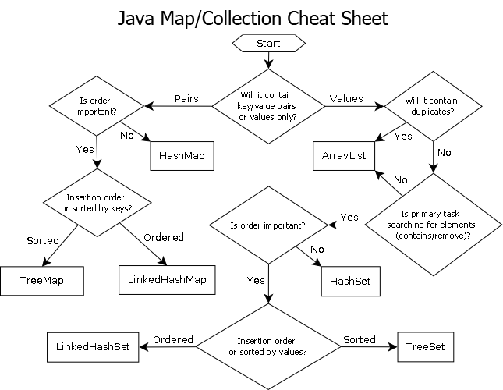
Java Map/Collection Cheat Sheet
Start
Is order important?
Yes
No
Insertion order or sorted by keys?
Pairs
Will it contain key/value pairs
Values
Will it contain duplicates?
or values only?
Yes
No
HashMap
ArrayList
No
Yes
Is order important?
Sorted
Ordered
No
TreeMap
LinkedHashMap
Yes
HashSet
Is primary task searching for elements (contains/remove)?
Ordered
LinkedHashSet
Insertion order or sorted by values?
Sorted
TreeSet

